VELALAR COLLEGE OF ENGINEERING
AND TECHNOLOGY (AUTONOMOUS)
(Accredited By NAAC with ‘A’ Grade )

DEPARTMENT OF ELECTRONICS AND COMMUNICATION ENGINEERING(12)
(Accredited by NBA)

INPLANT TRAINING / INTERNSHIP/
SUMMER PROJECT REPORT(14)

Submitted by

V.SANTHOSH (REG NO: ) (14)

in partial fulfillment of the requirements for the award of the degree(14)
of
BACHELOR OF ENGINEERING(16)
in
ELECTRONICS AND COMMUNICATION ENGINEERING(16)
Month and Year(16) Font Style Book Antiqua

VELALAR COLLEGE OF ENGINEERING AND TECHNOLOGY

DEPARTMENT OF ELECTRONICS AND COMMUNICATION ENGINEERING

BONAFIDE CERTIFICATE(16)

Certified that this INPLANT TRAINING / INTERNSHIP TRAINING / SUMMER PROJECT report is the bonafide work of
Ms. V.SANTHOS (REG NO: ) who carried out INPLANT TRAINING / INTERNSHIP / SUMMER PROJECT at THE INDIA CEMENTS LIMITED on the title “Operation of Kiln drive using Siemens distributed control system” from 03.06.2019 to 08.06.2019 (6 days).

Signature of the student

FACULTY INCHARGE HEAD OF THE DEPARTMENT
Dr.M.Nisha Angeline B.E, M.E., Ph.D. | Dr.K.Venkatachalam B.E, M.Tech, Ph.D.
Associate Professor | Professor
Department of ECE | Department of ECE
Velalar College of Engineering and Technology | Velalar College of Engineering and Technology
Thindal, Erode - 638012. (12) | Thindal, Erode - 638012. .(12)

CERTIFICATE FROM THE INDUSTRY

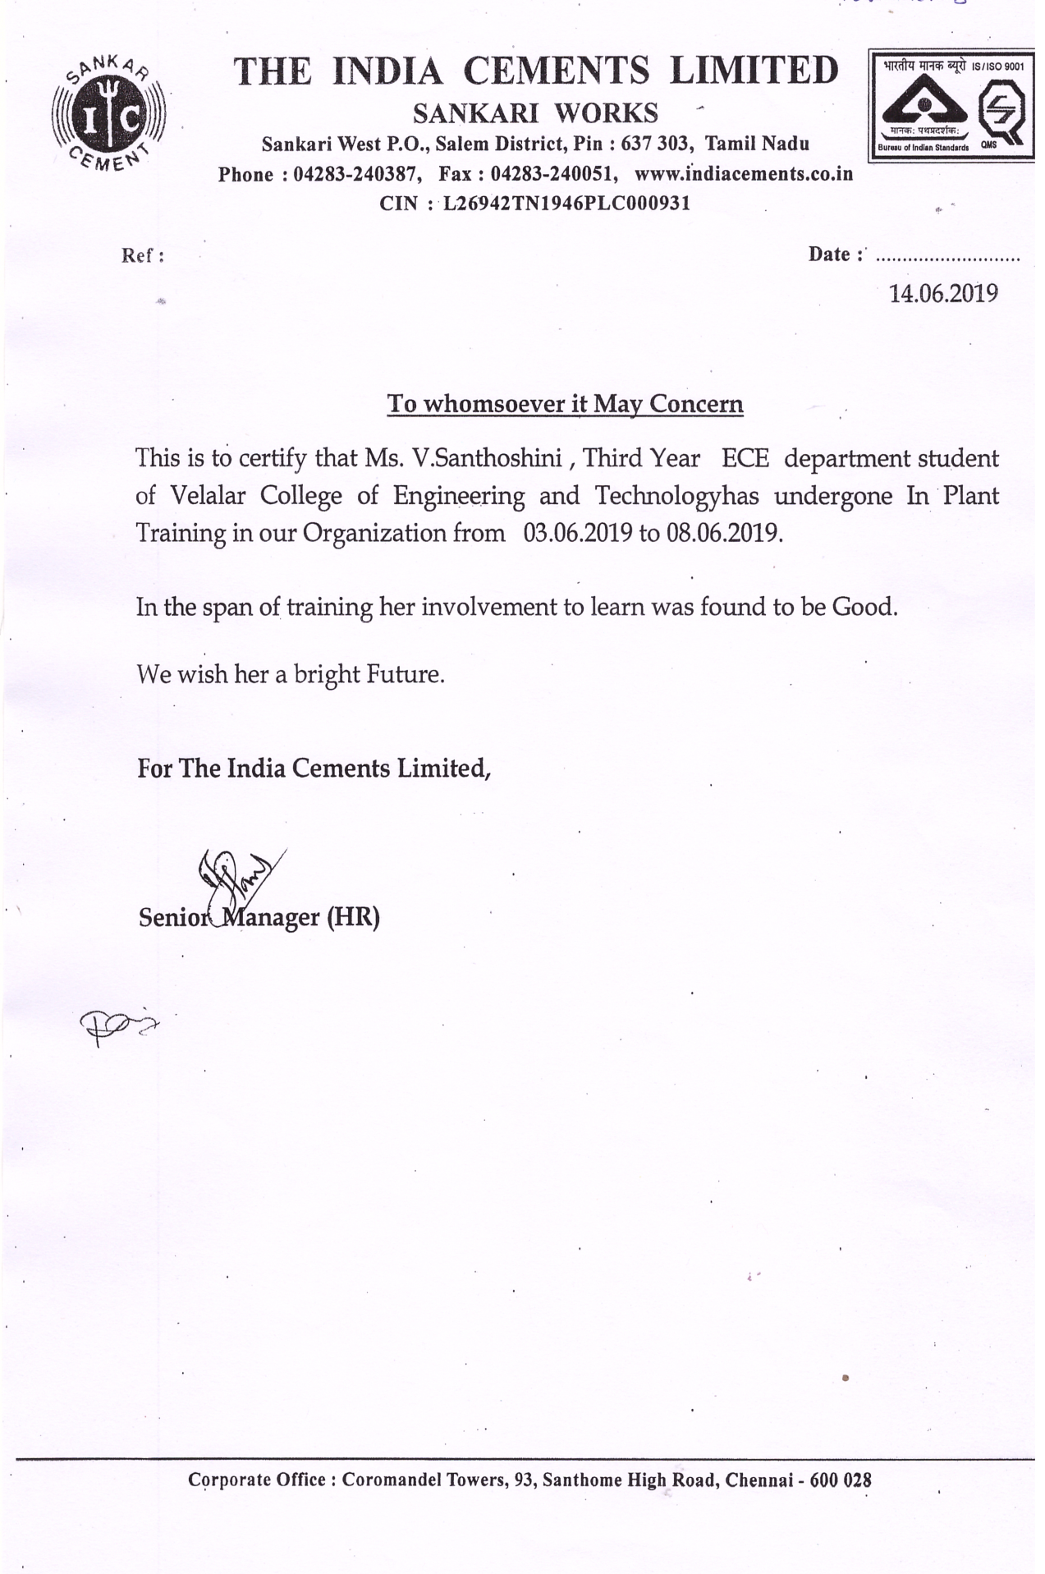

TABLE OF CONTENTS

S.NO. CONTENTS PAGE NO.

    - ABSTRACT
    - INTRODUCTION ABOUT THE INDUSTRY
    - COMPANY PROFILE
    - AREA / DOMAIN OF THE WORK / TRAINING
    - AIM & OBJECTIVES OF THE TRAINING
    - SCOPE OF THE TRAINING
    - PROJECT / TRAINING DETAILS
    - OUTCOMES OF THE TRAINING
    - CONCLUSION
    - ANNEXURE-1 (PHOTO GALLERY)
    - ANNEXURE-2 - REFERENCES (IF ANY)

LIST OF TABLES

S.No. | Table No. | Title | Page No.

LIST OF FIGURES
S.No. | Fig.No. | Title | Page No.

Title of the INPLANT/INTERNSHIP Training

ABSTRACT

Abstract is to be in one page of three paragraphs:
Introduction, About the Company/Orgn, etc.
Explnation of the Process / Training/…
Benefits obtained; POs achieved

Report (15 – 20 pages)
Page no. should start from this page only.
Page no. should be at the bottom center of the page

